# Brainstorm

**TIP**

You can select a sticky note and hit the pencil [switch to sketch] icon to start drawing!

### Before you collaborate

#### A little bit of preparation goes a long way with this session. Here’s what you need to do to get going.

##### 10 minutes

**1**

### Define your problem statement

#### What problem are you trying to solve? Frame your problem as a How Might We statement. This will be the focus of your brainstorm.

##### 5 minutes

**2**

### Brainstorm

#### Write down any ideas that come to mind that address your problem statement.

##### 10 minutes

**3**

### Group ideas

#### Take turns sharing your ideas while clustering similar or related notes as you go. In the last 10 minutes, give each cluster a sentence-like label. If a cluster is bigger than six sticky notes, try and see if you and break it up into smaller sub-groups.

##### 20 minutes

**4**

### Prioritize

#### Your team should all be on the same page about what's important moving forward. Place your ideas on this grid to determine which ideas are important and which are feasible.

**20 minutes**

### After you collaborate

You can export the mural as an image or pdf to share with members of your company who might find it helpful.

**Quick add-ons**

# & idea prioritization

## Use this template in your own brainstorming sessions so your team can unleash their imagination and start shaping concepts even if you're

###### Team gathering

Define who should participate in the session and send an invite. Share relevant information or pre-work ahead.

###### Set the goal

Think about the problem you'll be focusing on solving in the brainstorming session.

PROPER COMMUNICATION BETWEEN 3THE TEAM THE SUCCESS OF THE PROJECT AT ITS TERMINATION

FARMER SHOULD BE IN UPDATED MODE

THE WORKERS SHOULD ADOPT THEIR WORKS FOR EVERY SIUTATION

CLIMATE COULD BE CHANGED BUT THE WORKING NATURE OF AN INDIVIDUAL MUST BE AS THE BEGINNING

THE THOUGHTS AND PERPECTIVE OF EVERY INDIVIDUAL IDEA SHOULD BE CONSIDERED

INSTANT DEVELOPMENT IN SURVEYING IN THE AGRICULTURE FIELD

###### Person 1

The planting, maturing, and harvesting of crops all depend on consistent seasonal patterns.

EVERYONE SHOULD FOLLOW THE BASIC PRINCIPLES OF MANAGEMENT

THE ANALYSIS OF THE PROJECT SHOULD BE BY AN PROVIDING DATA OR ELSE BY AN EXTERNAL PROPER DATA

DO Q&A SESSION FOR DETAILED INFO

TAKE A SURVEY AROUND THE SURROUNDING

K.AISHWARYA

**Person 2**

HAVING A HONEST AND PROFESSIONAL ETHICS IN THE WORK GIVE A MORE CROPS PRODUCTION

S.SANDHIYA

###### Person 3

MANAGEMENT OF BOTH CROP AND INDIVIDUAL IS MORE ESSENTIAL TO MAKE AN ANALYSIS

A.THARANI

**Person 4**

GATHER INVENTORY INFO TO IDENTIFY STRENGTHS AND WEAKNESS

DETECTION OF WETHER/CLIMATE IS IMPORTANT

N.SUNITHA

Livestock depend

**TIP**

Add customizable tags to sticky notes to make it easier to find, browse, organize, and categorize important ideas as themes within your mural.

**Reducing tillage, expanding crop rotations, planting cover crops and reintegrating livestock into crop production systems**

###### Share the mural

**Share a view link** to the mural with stakeholders to keep them in the loop about the outcomes of the session.

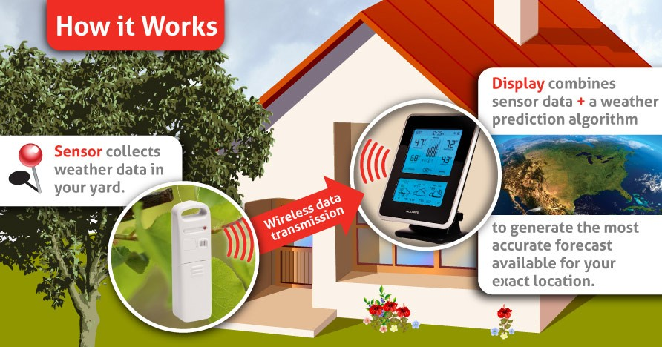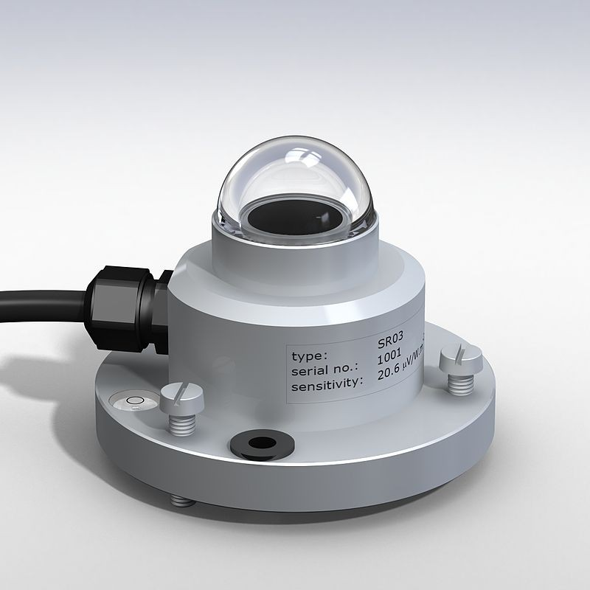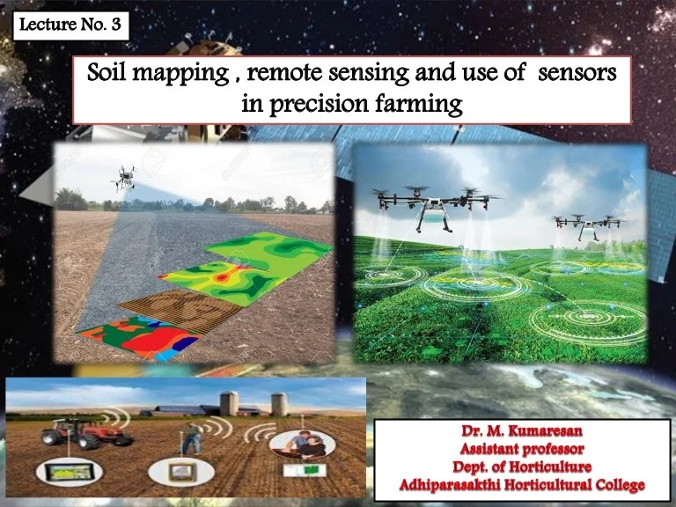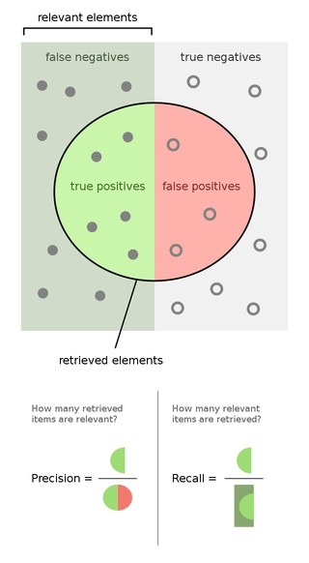

|  |  |  |  |  |  |  |
| --- | --- | --- | --- | --- | --- | --- |
|  | | | | | | |
|  |  |  |  |  |  |  |
|  |  |  |  |  |  |
|  |  |  |  |  |  |
|  |  |  |  |  |  |
|  |  |  |  |  |  |
|  |  |  |  |  |  |

###### Export the mural

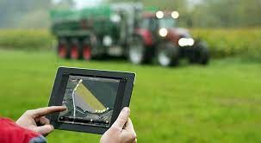Export a copy of the mural as a PNG or PDF to attach to emails, include in slides, or save in your drive.

## not sitting in the same room.

**10 minutes** to prepare

**1 hour** to collaborate

**2-8 people** recommended

###### Learn how to use the facilitation tools

Use the Facilitation Superpowers to run a happy and productive session.

[**Open article**](https://support.mural.co/en/articles/2113740-facilitation-superpowers)

**Key rules of brainstorming**

To run an smooth and productive session

Climate helps determine which pests and diseases will

ADVANTAGES

on feed, water, and a tolerable range of heat and humidity for healthy, productive growth.

### Keep moving forward

###### Strategy blueprint

Define the components of a new idea or strategy.

###### [Open the template](https://app.mural.co/template/e95f612a-f72a-4772-bc48-545aaa04e0c9/984865a6-0a96-4472-a48d-47639307b3ca)

**Customer experience journey map**

Stay in topic. Defer judgment.

Encourage wild ideas. Listen to others.

spread, and so how much time, effort, and money farmers must spend on herbicides, insecticides, and other defences.

### Importance

Beyond the harvest, patterns of temperature and weather affect the entire supply chain of storage and transportation that brings food from the field to the dinner plate.

If each of these

Understand customer needs, motivations, and

obstacles for an experience.

###### [Open the template](https://app.mural.co/template/b7114010-3a67-4d63-a51d-6f2cedc9633f/c1b465ab-57af-4624-8faf-ebb312edc0eb)

[**Share template feedback**](https://muralco.typeform.com/to/CiqaHVat?typeform-source=app.mural.co)

Go for volume. If possible, be visual.

tasks could get

done without any difficulty or cost, which would have the most positive impact?

DISADVANTAGES

Climate change can disrupt food availability, reduce access to food, and affect food quality. For example, projected increases in temperatures, changes in precipitation patterns, changes in extreme weather events, and reductions in water availability may all result in reduced agricultural productivity.

### Feasibility

The ocean soaks up most of the heat from global warming. The rate at which the ocean is warming strongly increased over the past two decades, across all depths of the ocean. As the ocean warms, its volume increases since water expands as it gets warmer. Melting ice sheets also cause sea levels to rise, threatening coastal and island communities. In addition, the ocean absorbs carbon dioxide, keeping it from the atmosphere. But more carbon dioxide makes the ocean more acidic, which endangers marine life and coral reefs.

Regardless of their importance, which tasks are more feasible than others? (Cost, time, effort, complexity, etc.)

###### Strengths, weaknesses, opportunities & threats

Identify strengths, weaknesses, opportunities, and threats (SWOT) to develop a plan.

###### [Open the template](https://app.mural.co/template/6a062671-89ee-4b76-9409-2603d8b098be/ca270343-1d54-4952-9d8c-fbc303ffd0f2)

[**Share template feedback**](https://muralco.typeform.com/to/CiqaHVat?typeform-source=app.mural.co)

**TIP**

Participants can use their cursors to point at where sticky notes should go on the grid. The facilitator can confirm the spot by using the laser pointer holding the **H key** on the keyboard.

Fossil fuels – coal, oil and gas – are by far the largest contributor to global climate change, accounting for over 75 per cent of global greenhouse gas emissions and nearly 90 per cent of all carbon dioxide emissions.

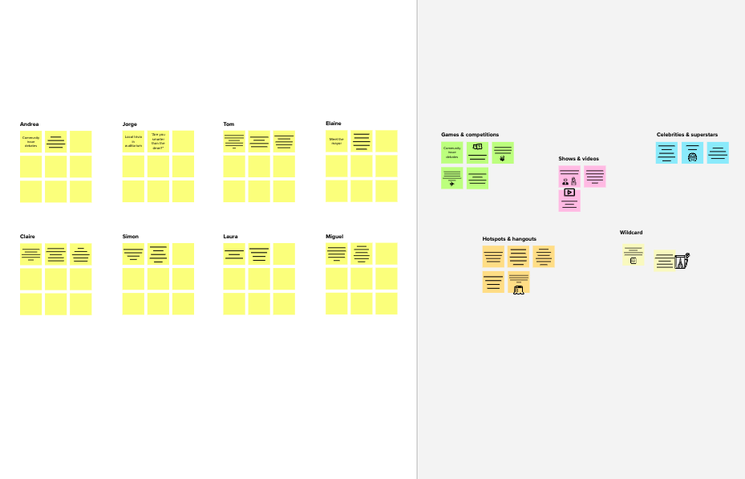

**PROBLEM**

Measured data show that global

te**H**m**o**p**w**er**m**at**i**u**g**r**h**e**t**s,**w**a**e**s **[**w**yo**e**u**ll **r**as

**pr**g**o**r**b**e**l**e**e**n**m**ho**s**u**ta**s**t**e**e**g**m**a**e**s**n**&**t]?**

emissions are rising

**Template**

**Need some inspiration?**

See a finished version of this template to kickstart your work.

[**Open example**](https://app.mural.co/template/e5a93b7b-49f2-48c9-afd7-a635d860eba6/93f1b98d-b2d2-4695-8e85-7e9c0d2fd9b9)